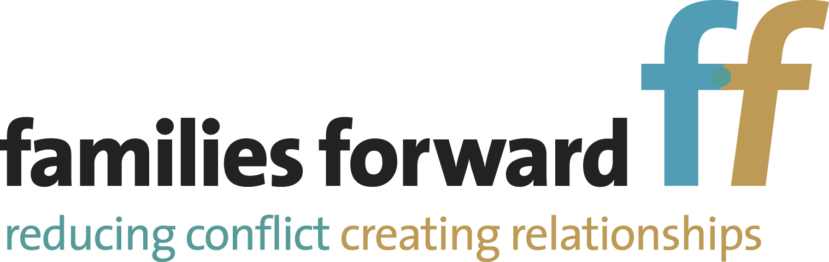

REFERRAL FORM
Letterbox/Indirect Contact

Referral fee enclosed | £30.00 (see terms and conditions for bank details)
Cost of Letterbox | £20.00 per occasion, plus postage if over 100 g

Frequency required  (circle as appropriate) | Weekly | Fortnightly | Monthly | Other  ………………
1. Parties

 | Resident Party | Non-Resident Party
Name
Gender | M/F | M/F
Address
(must be completed)
Telephone Number
Email address
Preferred method of contact
Solicitor details if applicable
(name, firm, address,contact telephone number
and email)

2. Children

Name | Gender | Date of birth | Name of carer
 | M/F
 | M/F
 | M/F
3. Court Order

Is this referral ordered by the Court  (If yes, a copy of the Order must accompany the referral form) | Yes | No

4. Referrer

Name
Agency and address

Telephone Number

5. Details of contact? (This section must be completed. Please give details, eg what can or cannot be sent; are there any reciprocal arrangements, etc)

6. We hereby undertake that we have answered the above questions to the best of our knowledge.

In submitting the referral, it is understood that:

- All information provided to Families Forward will be used for the sole purpose of the facilitation of letterbox contact
- Both parties are in agreement to the letterbox contact referral
- Both parties are in agreement to our terms and conditions
- Information held by Families Forward will be retained electronically for no more than three years
- Files may be shared with other agencies for quality assurance purposes only (if you are not in agreement to this statement, please advise Families Forward accordingly)
Parties
Resident Party | Non-Resident Party
Signed: | Signed:
Date: | Date:

Please return referral form to:
Families Forward
Oaktree House, 408 Oakwood Lane, Leeds LS8 3LG
Telephone 0113 235 9322
Email office@familiesforward.org.uk
Website: familiesforward.org.uk
Version: April 2022

TERMS AND CONDITIONS
LETTERBOX CONTACT

1. Letters and parcels should be sent to Families Forward unsealed and unwrapped. Families Forward will then check the contents to ensure they are appropriate for the children, or in line with any Court Order that is in place. If necessary, anything deemed to be inappropriate will be returned to the sender with an explanation as to why that decision has been made. All contents are noted in the family file. Families Forward will not wrap presents. If presents are received that are wrapped we will check with any legal representatives and/or CAFCASS to see if they should be sent unopened. In these circumstances Families Forward cannot be held responsible for their contents.

2. Families Forward will aim to send all mail out within 7 days of receipt. This should be borne in mind when sending commemorative cards, eg Eid, birthday, Easter. However, due to Christmas closure, any items intended as Christmas gifts should be received by Families Forward by 18 December in order to guarantee Christmas delivery. All items are sent by first class signed for delivery which is tracked and the receipt recorded on the family file. Where items are not delivered or collected, and then returned to Families Forward, the sender will be informed. The non-resident party would be liable for the cost of resending the items.

3. Where it is ordered by the Court that a session be held to handover the item(s) to a child, and their reaction monitored, this will be charged as a supported session at £45.00. The cost of this session is to be met in advance by the non-resident party, unless otherwise stipulated and agreed. Items to be handed over in this way, along with payment, should be received at least a week in advance to give time to arrange a session, and the items checked to ensure they are appropriate to be passed on. If they are not appropriate, the non-resident party will be informed as to the reasons why.

4. For the first contact, an invoice will be sent to the non-resident party after the event to cover the contact fee of £20.00 plus any additional postage costs. For all further contacts, the contact fee of £20.00 should be paid to Families Forward by cheque or direct to the bank before or along with the items to be sent. We will not post any items out until this is received. An additional postage costs will be invoiced and can be paid alongside the contact fee for the subsequent contact. The cost of indirect contact includes the postage for the first class signed for delivery of a small letter. However, if the cost of postage is greater than this, the full cost will be charged to the client account. The price of indirect contact also includes a letter to the Court to inform them of the frequency and appropriateness of contact, if this is requested in writing. Invoices will also be sent to the non-resident party for items sent from the resident party to the non-resident party (this could be school reports, photographs, cards from the children). Items will not be sent if the account is in arrears.

Payments should be made to:

Bank | Co-operative Bank | Account Name | Families Forward
Sort Code | 08 92 99 | Account Number | 65003165

5. Once delivery is tracked, a text message or email will be forwarded to the sender to inform of successful receipt of the item.

6. Families Forward reserves the right to close a file when there has been no activity for three months from non-receipt of a scheduled contact.

7. Feedback and complaints

7.1 Families Forward wishes to ensure that all those who use our service receive a courteous and professional response and one that is appropriate to their needs regardless of gender, race, language, religion or disability. We welcome and value your feedback.

7.2 If you are not satisfied with the way Families Forward is working with your family, you can make a complaint, in line with the Families Forward Complaints Procedure, which you can request at any time. In the first instance we encourage you to speak to your key worker, or Centre Manager. However, if your issue is not resolved by these means, you may wish to make a formal representation as described in the Complaints Procedure.

8. Quality Assurance

Families Forward is an enhanced accredited centre with the National Association of Child Contact Centres. In respect of the accreditation process, this agency will perform quality assurance checks on our work. Information shared for this purpose will be considered solely as a reflection of Families Forward and the quality of work they provide, and on the understanding that confidentiality is protected. Any party has the right to refuse to give such permission. No files will be shared unless both parties give permission for Families Forward to do so.

9. Security and retention of information

All records will be kept electronically using a secure recording system and will only be used for the purpose of facilitating the contact required. Unless there are safeguarding concerns that need to be referred to the appropriate agency, information will not be passed to any other party without the prior consent of the individual concerned, or their parent if they are under 16. Families Forward do not pass on any personal details to agencies not involved in the contact process. All documents are saved or scanned electronically and any paper documents will be confidentially disposed of. All electronic records will be retained for three years following closure, and then will be securely and confidentially deleted.

10. Declaration

The submission of the referral form is taken as an indication that both parties agree to the Terms and Conditions of Letterbox contact.

November 2022

Registered Company Number: 5323430 Registered Charity Number: 1139557
Oaktree House, 408 Oakwood Lane, Leeds LS8 3LG
Telephone 0113 235 9322 Fax 0113 240 1209

