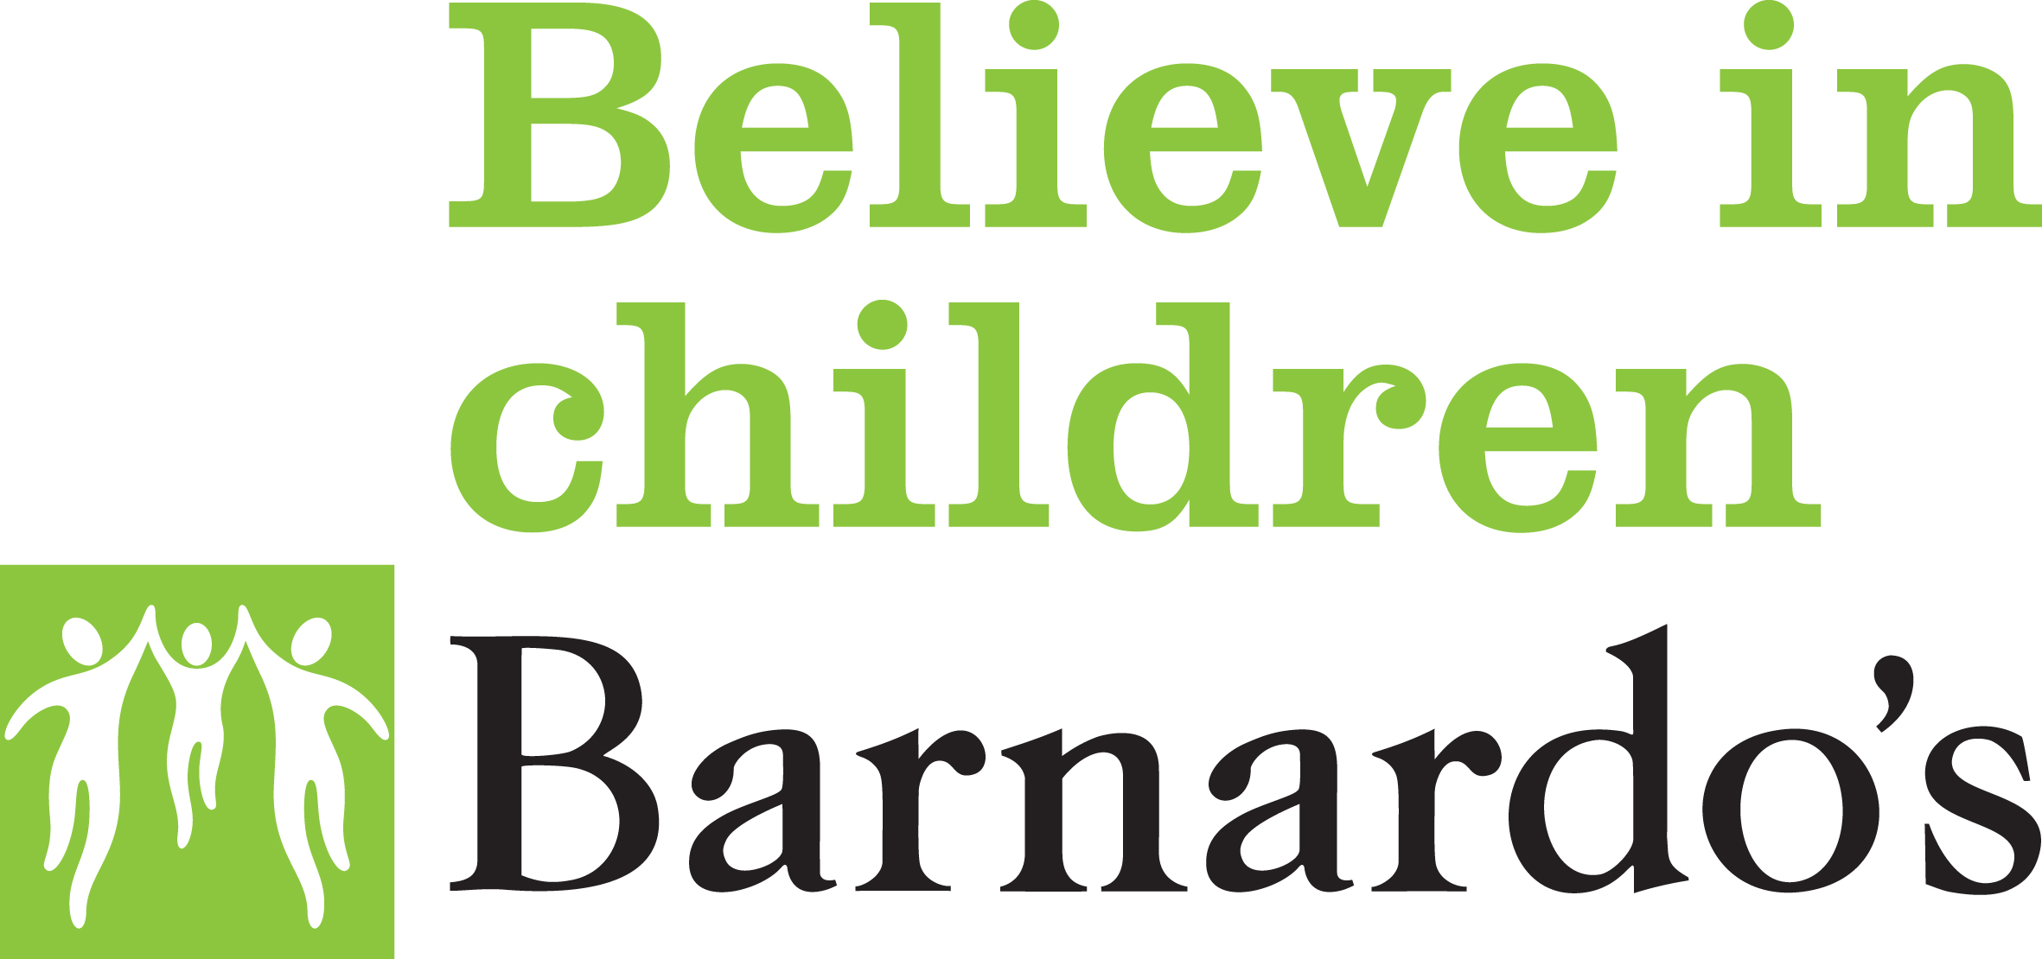
MILLSIDE CENTRE
ESOL Course

Class
Enrolment

By Wed 24th
February 2021

Class starts on:
March 3rd 2021

Venue:
Millside Centre
with additional remote learning

Class Times:
12:30pm till 2.30pm
Wednesday
(LIMITED SPACES 10 PER CLASS)

This is a 60-hour course that will also help with:
Written English,
Reading, speaking, Confidence Building
Basic ICT

English Course:
Speaking and
Listening
Reading
Writing
Basic ICT

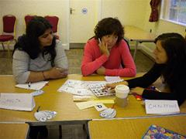
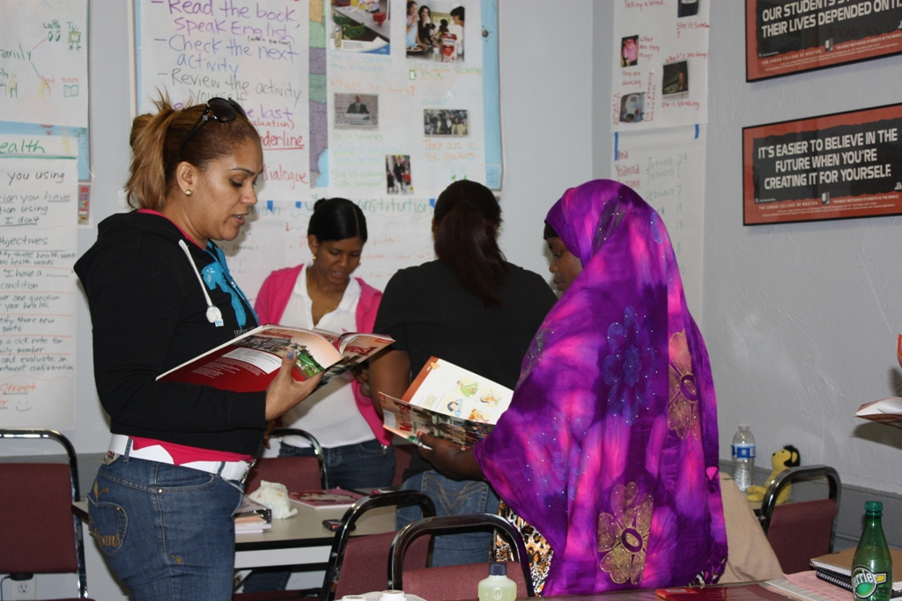

To be eligible for this course, you:

- Must be aged between 19 years and 65 years
- Must have low level of English language as this is a basic ESOL course
- Learners are asked to bring some form of identification

For further information contact

Millside Centre
Millside House
131 Grattan Road
Bradford BD1 2HS
Tel: 01274 409661
Email: info@millsidecentre.org

