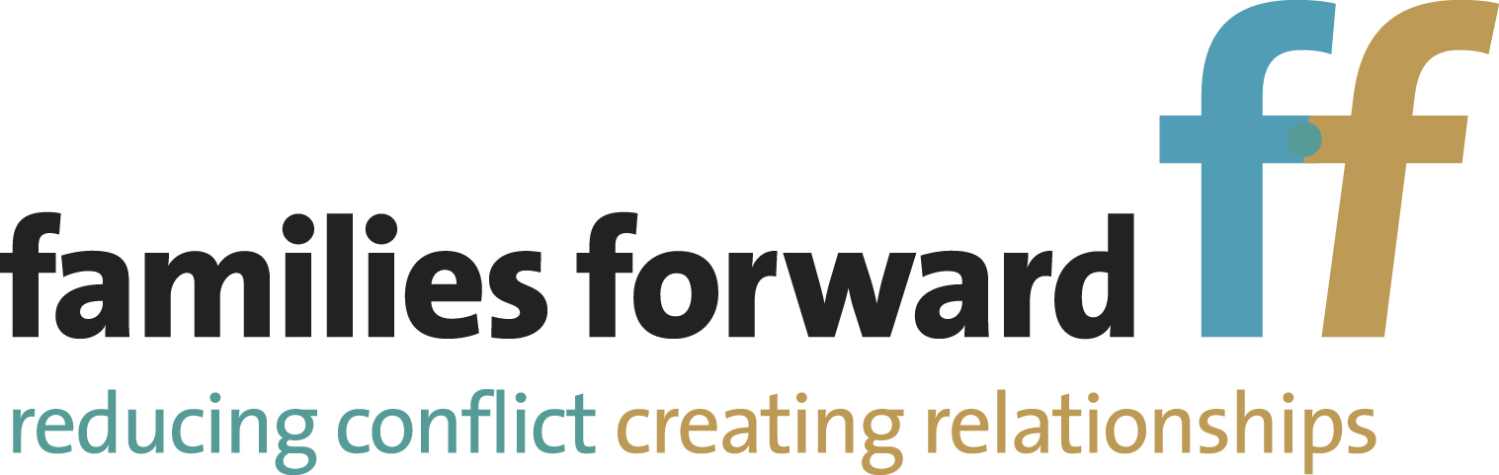

GUIDANCE FOR FAMILIES
COVID 19

We acknowledge that these are unusual times, and, to ensure that we keep both our families and staff safe, we need to put measures in place. We ask that you follow the guidance below, and sign the agreement to indicate that you are willing to do so.

When should I not attend contact? | If symptoms occur, no member of your household can attend the Centre. Please inform Families Forward as soon as you aware of symptoms, both for yourself and members of your household, so that we can make sure anyone who has been in contact with you can take appropriate measures. If you have been instructed to shield, please make sure you advise Families Forward accordingly. We will not offer contact to someone who is shielding.  Please ensure that you follow NHS guidelines
How will we maintain social distancing? | - Families Forward will, where possible, maintain 2m social distancing  - Appropriate signage has been posted within the building.  - All visitors to Families Forward will be asked to use the sanitiser provided at the entrance to the building and again outside the contact room. On leaving the building they should re-sanitise.  - Foot traffic throughout our centres will be monitored to ensure social distancing. Timings of sessions may change to allow for cleaning rooms between sessions and maintenance of social distancing within communal spaces.  - We will limit the number of staff and visitors in the building at any one time  - Staff will sit in the doorway of the contact room, rather than in it  - In order to allow staff time to clean between sessions, verbal feedback may be kept to a minimum after the session. Any further discussion following the session will be dealt with by phone call later in the week  - In respect of Fire Safety, you will be signed in and out of the Centre by workers
What other measures have we put in place to protect our staff and families? | - We are unable to provide refreshments or access to the kitchen at our Centres. If you wish to bring your own food and drink, you will also need to provide plates, glasses, cutlery, etc. However, you will be unable to wash these.  - Face coverings must be worn by every adult attending our Centres. These may only be taken off within the contact room, as long as both parents are in agreement. Staff will wear face shields during contact.  - We are unable to provide a waiting area for resident parents. They must leave the contact centre during contact, but must remain available on the telephone in case of emergency  - Only one adult may accompany children into the Centre  - We have reduced the number and type of toys in our contact rooms to ensure that these can be easily cleaned between sessions. However, parents and children should feel free to bring their own toys and games, which can then be taken away after the session.  - At the present time we can only accept online payments from parents for contact. The payment should be made on the day of contact. Slips with bank details will be available to be picked up at the Centres  - Observation notes will be provided electronically – please let Families Forward know if you change your email address

GUIDANCE FOR FAMILIES
COVID 19

I agree to follow the guidance from Families Forward regarding my attendance at the Centre

I agree that I will inform Families Forward if I start to show symptoms of Covid 19, before or after my contact

Signed
Date

